Military Services Training and Resources  
<https://sites.google.com/view/militaryservicesandtraining/home>   
  
Created by:  
Jessica Aubley, Valerie Coughlin, Drew Hoisington & Katie Lovick

The University of Akron  
  
Instructional Design

Fall 2019

For our project, we created a training for Stark State College’s Military Services. Currently, Stark State College has approximately 400 military-connected students. This includes Veterans, Active duty service members, Ohio National Guard members, Reserves and dependents using military benefits.

This project was designed using the planning documentation that we learned in the course. We worked closely with our Subject Matter Expert, Lisa Gilliland. All presentations used for this training we created by Lisa and Jessica to ensure they met the needs and learning strategies that are used to present professional development training to faculty members at Stark State College. Included in this report are the various forms we created during the analysis phase, design phase, development phase, implementation phase and evaluation phase.

**Table of Contents**

Instructional Design Project Proposal 4

Analysis Report 8

Design Report 21

Development Report 32

Implementation Report 39

Evaluation Report 42

# Instructional Design Project Proposal

**Project Title**

Our project title will be the “Military Services Training and Resources”.

**Subject Matter Expert Information**

Lisa Gilliland is the Coordinator of Military Support Services at Stark State College. Lisa works with Veterans and Active Service Members to provide resources, guidance, and direction needed to achieve academic and career goals. She also runs a small veterans lounge and is responsible for planning the Veterans Day program for the college.

**Student Information**

Our training will focus on educating Stark State Faculty members about the needs of veterans and active service members. All participants are educated and have at least a Bachelor's degree. It is known that the Faculty at the college are not big readers so all presentations must have audio to accompany them. This has been identified from past training experiences.

**Instructional Context**

This will be a training developed to educate the Faculty about the military, things Veteran students want instructors to know, issues that Veterans face, classroom strategies and the Leave of Absence Policy for Active Service Members.

**School/Institute Information**

This training will be developed for Stark State College.

**Identified Instructional Issues/Problems/Challenges**

At Stark State College, it has been brought to the attention of the Military Support Services that the faculty do not have a wide range of knowledge when it comes to their military students. This is concerning as Stark State has been selected to be a partner for education of US Air Force Service members. It is anticipated that the enrollment of service members will increase starting in Spring of 2020.  

Currently, this information is offered as a face-to-face training. It has been poorly attended because of scheduling issues for Faculty. Those who have attended have found it informative but have commented that they would have liked to have been able to refer back to what they have learned. Since this was a comment from several participants, it was determined that this training was better suited as an online training. The goal will be to develop an interactive online version of the training.

Since this is an internal training for Stark State College, it will be developed in the Blackboard learning management system. A version will also be developed as a Google Site so the team members of this project can use if for their online portfolio and it can be graded by Dr. Tsai. The team feels this is the best way to create this training since SSC does not allow guest access to Blackboard.

Several discussions have taken place on if Faculty need to complete the full training or just parts of the training. It has been determined that if they complete and pass all modules with an 80% or higher, they will receive a flag for their office door that identifies they are Military Trained Faculty. If they just want to educate themselves on various topics, they will be able to pick and choose what topics they review. The training will remain open so they can reference it as needed. There will be five modules for the training.

**Possible Timeline:**

|  |  |
| --- | --- |
| **Analysis Phase** | |
| 9/3 | Initial meeting with SME to define the purpose of the project, who the participants would be and a general idea of the needs and goals of the project. |
| 9/5 | SME to provide an outline that includes initial learning objectives, materials to be included and type of assessments to be developed for each module. |
| 9/16 | Meeting with SME for Analysis Phase toconduct a needs assessment data. |
| 9/18 | Team discussion on the meeting with SME. Creation of the draft of the Analysis Report. |
| 9/21 | Team to submit the Analysis Report to the discussion board for review. |
|  | |
| **Design Phase** | |
| 9/30 | Team discussion on the materials/activities/strategies SME defined as part of the Analysis Phase. Creation of the draft of the Design Report. |
| 10/1 | SME to review the team’s suggestions and provide feedback to be used in the report. |
| 10/2 | Team to submit the Design Report to the discussion board for review. |
|  | |
| **Development Phase** | |
| 10/3 | SME to provide team with the PowerPoint Drafts to be used for each Module. |
| 10/8 | Team discussion on the development of the prototype. Creation of the draft of the Development Report and prototype. |
| 10/9 | Team to provide SME the draft of the presentation for Module 1 |
| 10/11 | SME to come to Jessica’s office to record voiceovers for Module 1. |
| 10/12 | SME to review the final presentation to be used in Module 2. This includes voiceovers and closed-captioning. |
| 10/16 | Team to provide SME the draft of the presentation for Module 2. |
| 10/18 | Team to submit the Development Report to the discussion board for review. |
| 10/18 | SME to come to Jessica’s office to record voiceovers for Module 2. |
| 10/23 | SME to review the final presentation to be used in Module 2. This includes voiceovers and closed-captioning. |
| 10/23 | Team to provide SME the draft of the presentation for Module 3. |
| 11/1 | SME to come to Jessica’s office to record voiceovers for Module 3. |
| 11/6 | SME to review the final presentation to be used in Module 2. This includes voiceovers and closed-captioning. |
|  | |
| **Implementation Phase** | |
| 11/4 | Discussion with SME regarding implementation plan for the training. This will include the soft implementation and the full implementation. |
|  | |
| **Evaluation Phase** | |
| 11/4 | Team brainstorm session regarding evaluation questions for both Formative and Summative Evaluations. |
| 11/5 | Discussion with the SME regarding evaluation questions and those who would be used for this evaluation. |
| 11/5 | Those asked to evaluate were enrolled in the training and sent an email request to do so by 11/9 |
| 11/10 | Evaluations to be reviewed and discussed during a call with SME |
| 11/11 | Evaluation report to be created and submitted for Dr. Tsai’s review |
| 11/14 | Updates to be made to implementation and evaluation reports |
| 11/25 | Team discussion on the development of the Final ID Project Video Presentation. |
| 12/3 | Final Report and Video URL posted. |

# Analysis Report

At the request of the Subject Matter Expert Lisa Gilliland, Coordinator of Military Support Services, the students enrolled in the Fall 2019 Instructional Design course (Jessica Aubley, Valerie Coughlin, Drew Hoisington & Katie Lovick) will develop a self-guided online training that focuses on providing faculty members at Stark State College information about the military, things Veteran students want Instructors to know, issues that Veterans face, classroom strategies and the Leave of Absence Policy for Active Service Members.

The Military Service office at Stark State College currently serves 400 Veterans and Active Military Students. This is 1% of the student population at Stark State College. The college has made a commitment to focus on the diverse needs of our students, therefore, it is critical that the faculty understand the needs of this student group.

Military Service currently offers this training face-to-face about once a year. Attendance has been low and it’s been difficult for Lisa to coordinate the speakers that are needed for the training. There have been requests from faculty that they would like to be able to complete the training on their own time. These issues have led to her request that the Instructional Design team create an online version of the training.

Lisa has provided information about the items that need to be in the training, this includes PowerPoint drafts that will be reformatted into Articulate Storyline interactive lectures, information regarding the Military Services Office and learning objectives for each module. She has also offered to coordinate with those who presented in the live trainings to come record audio for the interactive lectures. She will have bimonthly meetings with Jessica to ensure everything is on target on the project. This training development must be completed during Fall 2019. The plan is to start offering it to faculty in the Spring of 2020.

The development of this training will be in Blackboard. This is the learning management system that Stark State College uses. Per the Policy and Procedures Manual, all courses and trainings must be housed in this system. Since it is an internal system, Jessica will work with Lisa to design and develop the training in the system. For the purpose of review by Dr. Tsai, our team will create a replicated version using Google Sites.

**Instructional Problem:**

There are several instructional problems that have been identified:

1. The current training that is offered is a face-to-face training. It has been offered on various dates and times but attendance has been low.
   1. Full-time faculty members have provided comments that they don’t have time during the day to attend a four-hour training due to teaching courses, office hours and committee obligations. These items are all part of their contracts therefore they must come before optional trainings.
   2. Adjunct faculty members have commented that they are interested in learning how to support Active Service Members and Veteran students but they do not want to take vacation time from full-time positions to attend this training.
2. Military Services has struggled to coordinate times for trainings.
   1. There are various presenters they use for the face-to-face training. Their schedules do not always align. This is impacted the frequency for when the training can be offered.
   2. Those who have attended the face-to-face trainings have commented they enjoyed learning about supporting the students but would like to have somewhere to reference the materials they have learned. Currently, there is no place on the Stark State systems where faculty can review the PowerPoints and resources covered in the face-to-face training.
3. Those that attended the face-to-face training were given a flag for completion. This indicates to Military Students that these faculty members are trained to assist them. Several Military Students have commented that when they have visited these faculty members in the past, they were not helpful answering their questions.

The face-to-face training does not have a method of assessment, therefore, Lisa cannot gauge the Faculty’s understanding of what has been covered in the training.

**Needs Analysis:**

Currently, the faculty has very little knowledge about Military Students. The population of Military Students at Stark State College is growing so it is critical that faculty be trained. In Fall of 2019, the college was selected to be a partner for education of US Air Force Service Members. It is anticipated that the College’s enrollment of Active Service Members will increase with this enrollment beginning in Spring 2020.

Phase I: Planning: Due to Stark State College’s guidelines on conducting surveys we felt it was best to interview our Subject Matter Expert to understand the current environment and needs of this online training. Lisa provided us with several reasons that this training was needed. These are covered in the interview below. As part of the interview, we discussed the survey she conducted regarding the needs of a trying like this. It was sent to faculty members to understand their request for an online training. When surveying faculty members, we discovered that they know there is a Military Services office but were unsure of what assistance the office can provide. They were also unsure of the difficulties that veterans faced in their classrooms.

Phase II: An interview with Lisa was conducted, regarding the comments she had from faculty regarding the times that the training was scheduled and issues getting coordinating speakers for specific dates for presentations. Many faculty members have stated time is certainly an issue, especially during the day. Attending a four-hour training is hard to manage due to teaching courses, office hours and committee obligations. Vacation time was also brought up in regards of having to take it to attend training sessions. Surveys Lisa conducted showed that faculty would like an online training that they could view at their leisure. They prefer short modules that do not take more than 45 minutes to complete. Requests for specific training subjects included information on why these students struggle with the structure of school, how the structure differs from the military, the services that are available on campus for these students, classroom strategies that can be used and an explanation on the Leave of Absence Policy.

Phase III: Analyzing the data shows an interest in supporting this project as faculty members show a desire for the trainings and this could increase enrollment in the courses. As of now, turnout has been low and focusing on the needs of the faculty could help increase enrollment.

Phase IV: Compiling a Final Report will focus on creating a prototype (Blackboard) site that we can use and modify for our training purposes. We believe this will allow for greater enrollment in the training sessions and hit on what feedback we were given during the interview process to help the faculty.

**Learner Analysis:**

The learners have been identified as the faculty at Stark State College. Currently, there are 198 Full-Time faculty Members and 740 Adjunct faculty members. It’s important to note that due to Stark State College’s policies the Instructional Design team was prohibited in surveying Faculty. The conclusions below come from the information that Lisa and Jessica were able to supply about the Faculty.

General Characteristics of Learners (faculty Participants):

|  |  |
| --- | --- |
| **Characteristics Reviewed** | **Details** |
| Age | faculty members range from 27 to 76 years old.  A specific breakdown by age group was not available. |
| Gender | faculty members consist of both males and females.   A specific breakdown by gender was not available. |
| Language | The majority of faculty members first Language is English but the team is aware of 20 faculty members who have other languages as their native tongue.  These languages include Korean, Mandarin, Spanish and Turkish. |

Personal/Social Characteristics of Learners:

|  |  |
| --- | --- |
| **Characteristics Reviewed** | **Details** |
| Maturity Level | The faculty members are very mature. |
| Motivation Level | Motivation varies among faculty members. Those who enroll in this training will have a high level of motivation. This is assumed since they are enrolling in an optional training. |
| Expectations | Ability to support Military Students Student engagement Student retention  Understanding of Policies |
| Vocational aspirations | Adjuncts - Possible promotion to Full-time Faculty Full-time faculty- Advancement in Rank |

Academic Information of Learners:

|  |  |
| --- | --- |
| **Characteristics Reviewed** | **Details** |
| Education Completed | At minimum, all faculty have at least a Bachelor's degree.  The majority of the faculty have a Master’s degree or higher. |
| Training Levels Completed | 520 faculty members (70% of all faculty Members) have completed an online self-guided Blackboard Basics course that educates them on how to use the Blackboard LMS. Required for all online instructors.  220 faculty members (30% of all faculty Members) have completed an online self-guided Starfish training course. This training focuses on using the Starfish retention tool. Required by some departments.  288 faculty members (39% of all faculty Members) have completed a Teaching Online course that educates them on effectively creating course content and teaching online. This is an online facilitator led training. Required for all online instructors. |

It should be noted that Stark State College has a Help Desk and a Blackboard Student blog that will be used to support those who have not taken any online training.

Entry Characteristics of Learners:

|  |  |
| --- | --- |
| **Characteristics Reviewed** | **Details** |
| Prerequisite Skills | Familiar with Blackboard and how to perform tasks in the system  Understanding of computer skills including how to increase volume, play and pause videos and save files. |
| Previous or Current Experience with Topic | Several faculty members are Veterans.  All faculty have received emails that are sent from Military Services regarding policies for Active Military Students. |
| Reading Levels | Average reading level is of a Master’s student at a University. |
| Attention Span | Can maintain attention for several hours. |
| Attitude Towards Work or Subject | Positive attitude about learning new ways to support our student population. |

Learning Styles of Learners:

Information on the Faculty’s learning styles was not available. Jessica has created training for the last five years for faculty at this institution. During this time, she has learned that it is important to create materials that meet the principles of Universal Design for Learning. This allows the faculty members the option of learning with whichever materials fit their needs. The content that has been most successful include has developed as an interactive presentation where the faculty member can decide if they want to listen to the presenter or review the slides and read the closed-captions that are supplied.

Instructional Environment of Learners:

|  |  |
| --- | --- |
| **Characteristics Reviewed** | **Details** |
| Policies | This is an optional training. Faculty members can teach without completing this training.  There is no compensation for the training. |
| Technology | Computer with sound  Internet access |
| Resources | Full-time faculty are supplied computers in their offices.  Adjunct faculty have offices throughout the campus where they have access to computers. |

**Veterans and Active Service Members Analysis:**

It is critical that we understand the characteristics of Veterans and Active Service Members. We have created an analysis on these students that will be used as a guide when we are creating presentations regarding their characteristics and needs.

General Characteristics of Veterans and Active Service Members:

|  |  |
| --- | --- |
| **Characteristics Reviewed** | **Details** |
| Age | These students range from 18 years old to 65 years old.  A specific breakdown by age group was not available. |
| Gender | Consist of both males and females. The majority being males, about a 30% to 70% split.  A specific breakdown by gender was not available. |
| Language | All speak English. |

Personal/Social Characteristics of Veteran’s and Active Service Members:

|  |  |
| --- | --- |
| **Characteristics Reviewed** | **Details** |
| Maturity Level | This is a very mature group of students. They are used to structure, accountability and direct orders. These students tend to do well with teamwork, are goal driven, respectful and committed. |
| Motivation Level | They tend to be a motivated group of students but become easily frustrated with learning new systems, unclear directions and terminology differences. |
| Expectations | This group prefers clear directions and specific goals. |
| Vocational aspirations | To obtain a certificate, new skills or an Associate’s degree. |

Academic Information of Veteran’s and Active Service Members:

|  |  |
| --- | --- |
| **Characteristics Reviewed** | **Details** |
| Education Completed | Most have the educational level of a High School graduate. Some have taken courses towards an Associate Degree. |
| Training Levels Completed | Many complete training in the Military. This varies by student. At Stark State College they are required to complete a New Student Orientation that helps them understand services the college offers and how to navigate the college systems. They can complete this orientation at a face-to-face session or [online](https://www.starkstate.edu/nso/). |

Entry Characteristics of Veteran’s and Active Service Members:

|  |  |
| --- | --- |
| **Characteristics Reviewed** | **Details** |
| Prerequisite Skills | These students bring some great skills to the college including problem-solving skills, ability to work under pressure, adaptability and leadership. |
| Reading Levels | These students vary in reading skills. They are used to materials that utilize direct, concise, and non-persuasive writing as they see in the Military. |
| Attention Span | Have strong attention spans. |
| Attitude Towards Work or Subject | These students’ attitudes can very. Most are positive but they require specific instructions. If they feel their Instructor is not providing the information they need, they tend to shut down and not participate in class or turn in assignments. |

**Task Analysis:**

1. Introduction to Military Services Office
   * 1. Mission of the office
     2. How Military Services assist students
     3. Location and hours of Military Services Office
     4. Military Services staff information
     5. Website location of resources for students
2. United States Military Branches and Structure – Five Branches of the Military
3. How to refer to service members of each branch
4. Structure and hierarchy of the military
5. Difference between active duty and reserves
6. Characteristic of the Military culture and how they differ from the college environment
7. Characteristic of Veteran Students
8. Items Veteran Students want faculty to know – Post Military Identity
9. Structure of Military Vs Education
10. Stress/Anxiety students face
11. Academic involvement in a classroom
12. Safety and awareness
13. Boredom/Letdown
14. Campus culture
15. Challenges with Processes
16. Physical disabilities
17. Mental disorders
18. Visible and Invisible Scars - Accommodations for physical disabilities
19. What invisible scars are
20. Different types of invisible scars
21. Impact of invisible scars on education
22. Veteran-related resources for invisible scars
23. Accommodations for invisible scars
24. Classroom Strategies and Tips for Faculty - How to approach a Veteran in class
25. The Military Leave of Absence policy
26. Faculty and Student options in the case of military leave of absence
27. Examples/scenarios of successful course completion

# Design Report

After reviewing the data from the analysis phase, we started the construction of our website using Google Sites. We developed objectives for each module lesson and supplemented each module with materials such as presentations, videos, and assessments for the module. These modules will serve as our content for our training sessions.   
  
Task Analysis

When beginning this training, faculty should have general knowledge of how to use Blackboard services, including their log-in information. They should be equipped with basic skills using their current learning management system, such as:

* Logging into Blackboard
* Maneuvering around pages on Blackboard
* Ability to open and watch videos
* Ability to open documents
* Ability to listen to lectures
* Ability to use Google Forms to take quizzes
* Ability to return to Blackboard if a link takes them to a new page

**Performance/Learning Objectives**

Overall Objectives

* Instructors at Stark State College will be able to assist Veteran and Military students by educating them on services available.

Module Objectives

* Identify the five branches of the United States Military and how to refer to each branches service members
* Recognize the structure and hierarchy of the military
* Understand and define the differences between "active duty" and "reserves"
* Identify characteristics related to military culture and how that differs from the college environment
* Identify and understand the challenges vets have from transitioning from the military to the college environment.
* Explain the concept of an “invisible scar”
* Identify the different types of “invisible scars” and how they impact education and learning
* List veteran-related resources
* Identify possible accommodations and the process to obtain accommodations
* To understand and identify culturally sensitive ways to approach and discuss military experience
* To identify potential classroom challenges and strategies for success
* To improve the classroom experience for veterans on campus
* To identify and understand the Military Leave of Absence policy for Stark State College
* To identify and understand faculty and veteran options in the case of Military Leave of Absence
* To review examples/scenarios of successful course completion

**Instructional Strategies**

The following strategies will be utilized:

* *Technology*: Faculty members will need to be able to access and engage with online Blackboard type of learning platform
* *Differentiation*: Multiple resources will be provided for faculty members to use for comprehension of the material.
* *Formal/Summative Assessment*: Faculty members are to complete an assessment at the end of each module.

**Instructional Sequence**

The Blackboard Management System, as well as the Google Site, are set up so that each module can be viewed in a sequential manner. The objectives are stated at the beginning of each module page, with a presentation that gives pertinent information to the topic. There may be a video, as well, which will further develop the learner’s understanding of the objective. After reading the objective, listening/viewing the presentation and possibly watching the video, the learner will then take a module assessment using a Google Form. This will allow the SME to better understand what the learner needs more information on, once they have completed all of the modules.

**Content Analysis**

By using the website, learners will be able to navigate through the homepage. From there they are able to view each of the lessons which contain 5 modules. Within each module are there are overviews of what the learners will learn. Next will be the stated learning objectives, materials and an assessment. There are also videos in which the participant will complete as well that are either from YouTube or embedded in html format. The modules are United States Military Branches and Structure, What Veterans Want You to Know, Visible and Invisible Scars, Classroom Strategies and Tips, and Leave of Absence Policy.

**Site Organization**

The site organization will follow the standard template set by eStarkState. This template is used for Quality Matters purposes to ensure participants are seeing the standard navigation that they are familiar with.   
The page organization will be:

Homepage

Start Here!

Lessons

* Module 1 - United States Military Branches and Structure
* Module 2 - Top 10 List - What Veterans Want You to Know
* Module 3 - Visible and Invisible Scars
* Module 4 - Classroom Strategies and Tips
* Module 5 - Leave of Absence Policy

Grades

Contact

Help

*Site Organization*

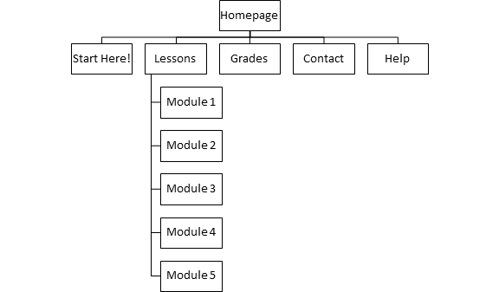

**Site Navigation**

All pages have a consistent look and navigation. The navigation is located on the top of each page. There is also a search option that the participant can use if they are looking for something specific.

When the participant clicks on the website, they will be taken to the homepage. On this page, there will be a welcome message explaining information about the course and advising them to visit the Start Here! page to begin.

*Site Homepage  
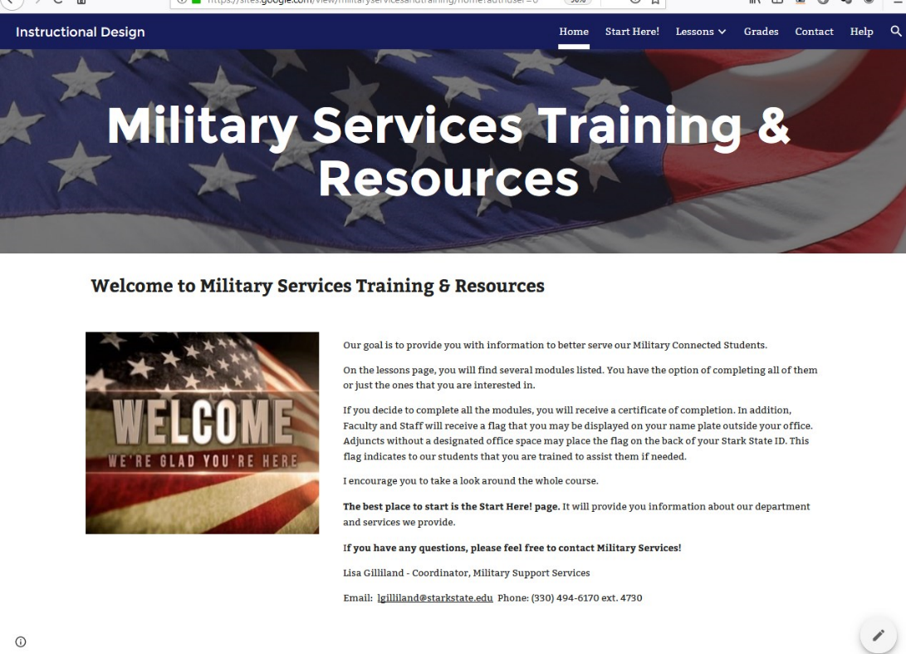*

The Start Here! Page contains items that the Military Service office felt was important for participants to know before they started the training. This includes a welcome from their department, their office information, link to resources, training objectives and directions on what to do next.

*Start Here!  
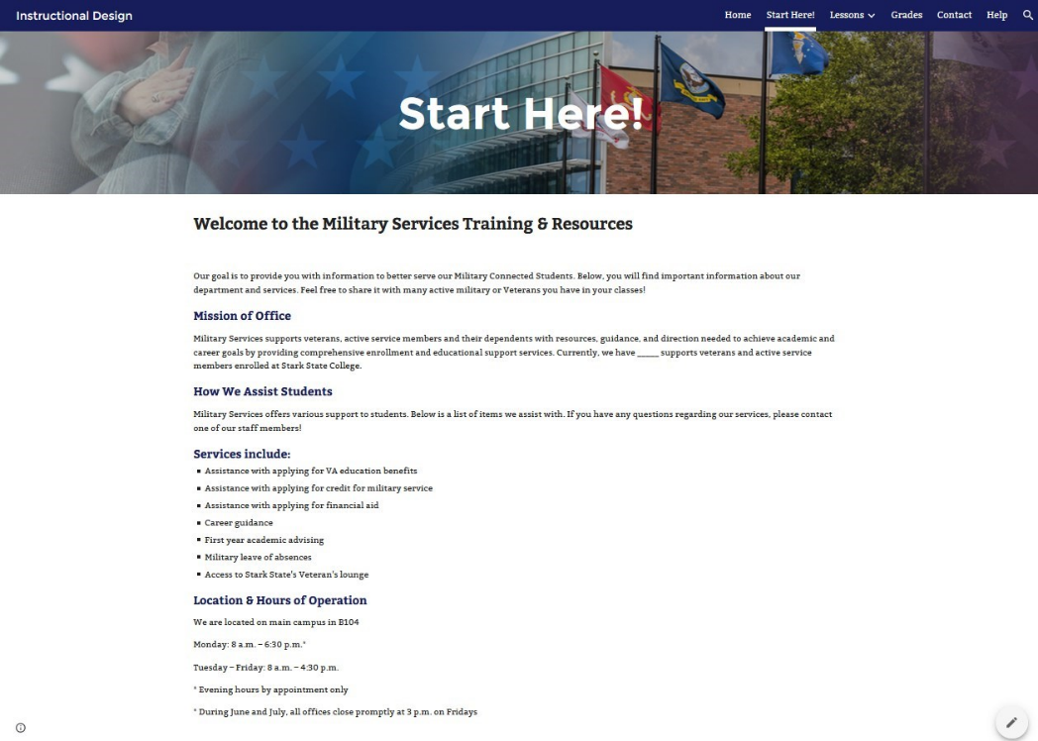*

The Lessons page contains links to all Modules of the training. The user can navigate it in two ways. First, they can click on the main Lessons title and see a list of all the Modules. Second, they can click on the individual Module title and go directly to the Module they desire to complete.

On each Module page, there is an overview of what the participant will learn, the stated learning objectives, materials and an assessment. The same layout is used on all Module pages for consistency purposes.

*Lessons Page with all Modules Listed  
  
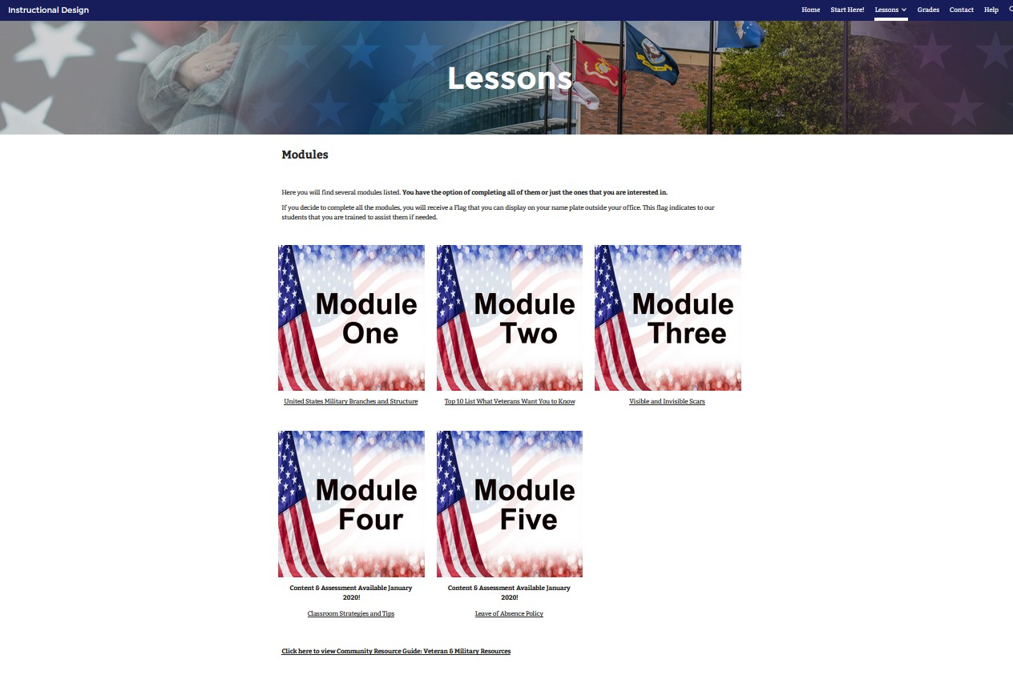*

*Example of a Specific Lesson Page  
  
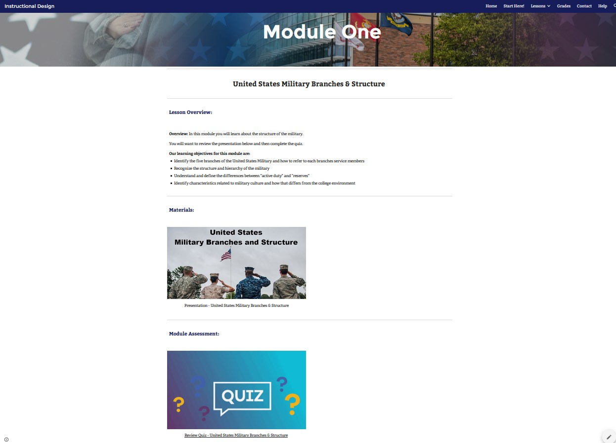*

The grades page is designed with a video and directions for signing in the gradebook. The gradebook is linked below the directions. For the actual training in Blackboard, the built-in gradebook will be used.

*Grades Page*

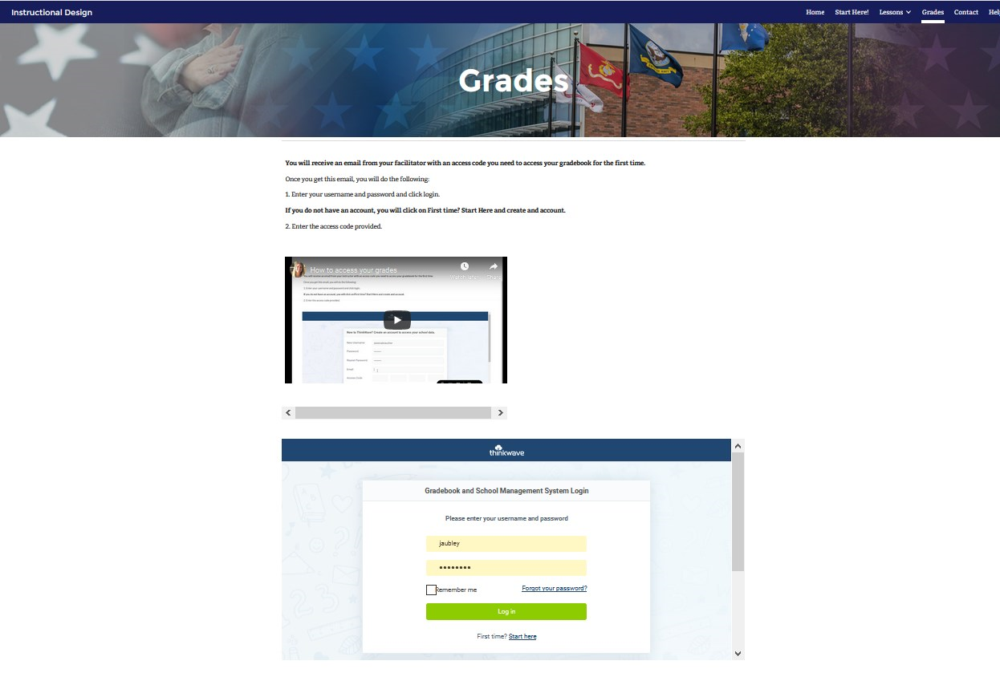

The Contact page has Lisa’s contact information on it. Since she will be conducting the training, it is critical for participants to be able to contact her. Her picture is included, that way participants can recognize her, if they opt to set up a face-to-face meeting.  
  
*Contact Page*

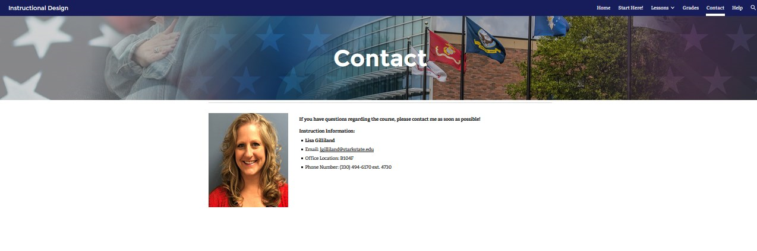

The Help page has videos to help the participants if they have difficulty with items such as playing the interactive lectures, enlarging videos and taking the assessments.

*Help Page*  
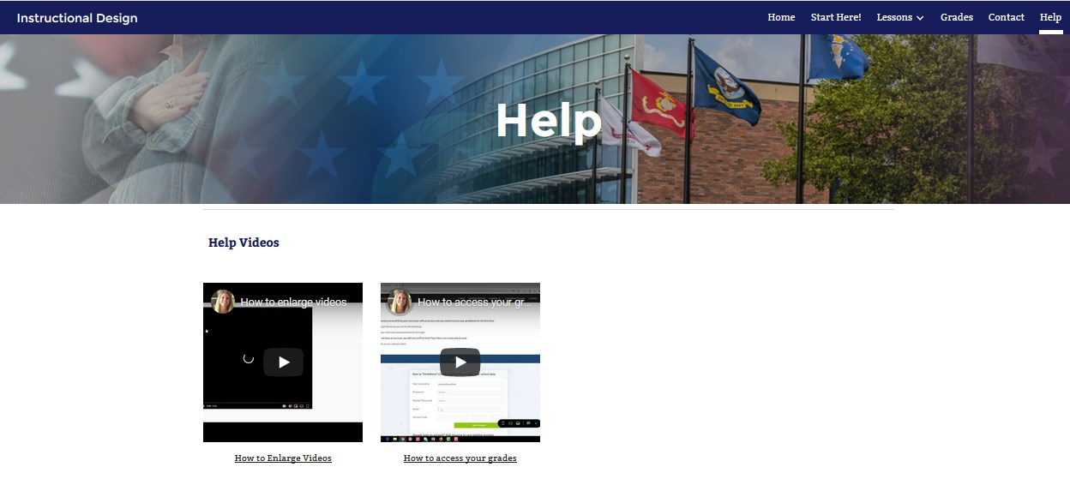

## Site Conventions

## On the Google Site prototype, the view of the site is consistent throughout each page. The title banner for each page is a military themed photo, with white simple font. Each page has a few sections, with the font being consistent throughout for the headings, which are blue and a slightly larger font. The information under the headers is in black, smaller font. The “Start Here!” page and the “Contact” page include pictures of the Veterans Services staff, using consistent font, colors, and sizes for each descriptor. The “Modules” page has a photo with a flag that links to each page. It is consistent for each of the modules.

## Formats/Media

## To gain access to our site, participants will need to access the internet by using a computer, tablet, or smartphone. Once on the internet, participants will need to click on the link to access the site. The site will have internal and external links. The site will include videos that are YouTube embedded. External links are in html format. No additional plugins are required.

# Development Report

This report focuses on the development of the training.   
**Media Selection Rationale**

Since this is an internal training for Stark State College, it will be developed in the Blackboard learning management system. This gives access to all employees who need the training and they can complete it at their own pace. Currently, this information is offered as a face-to-face training. It has been poorly attended because of scheduling issues for Faculty. Those who have attended have found it informative but have commented that they would have liked to have been able to refer back to what they have learned. Since this was a comment from several participants, it was determined that this training was better suited as an online training. The goal will be to develop an interactive online version of the training. These modules use video presentations that were developed to alleviate the strain of scheduling speakers with every employee’s schedule. The faculty scheduling errors made it difficult so speakers were filmed and these presentations are assessed through summative quizzes using Google Forms. This assessment platform is used by the Stark State College and integrates with Blackboard seamlessly.

**Issues of Message Design**

The focus of this training is to provide educators an opportunity for professional development in a convenient way. This training course will be available to all employees looking to be an advocate for Veterans at the Stark State College and focuses on the concerns employees had in regards to attending trainings in the past. The training modules are targeted for employees to complete at their own pace and have been streamlined for easy access and completion. Through media presentations and assessments on the Blackboard site of Start State College, these modules are created for educating Stark State Faculty members about the needs of veterans and active service members. This platform provides the easiest opportunity for faculty at Stark State College to complete the training and receive a certificate to advocate and be there for Veterans on and off campus.

**Instructional Resources**

During this project, we worked with our Subject Matter Expert to create the resources that would be used. Since this is a specialized training, most resources were custom created for the project. This included the module lectures and assessments.

Each lecture began as a PowerPoint draft that our Subject Matter Expert created. These drafts were then provided to Jessica who created Articulate Storyline versions of them. Jessica added imaging and interactivity to many of the slides. Once this was done, the Subject Matter Expert provided an audio script and scheduled the person she chose to read the script. After the audio was added, Jessica closed-captioned each presentation to ensure it met the ADA standards that are used for Stark State College courses. Over the years, eStarkState has determined that the best way to present content to faculty is to have both visuals and audio. That is why we chose to use Articulate Storyline as the technology for the presentations.

For the assessments, our Subject Matter Expert worked with Jessica to create questions that thoroughly assessed the learning objectives for each module. This was a helpful process as it allowed us to understand if we used the best measurable verbiage for each learning objective that was created. This was a critical element for the project as Stark State College focuses on developing all trainings and courses using the Quality Matters rubric.

Additional resources in this training include website links that provided to us by our Subject Matter Expert as references for specific topics that she felt the participant may want information on. There is also a video that was recorded during a presentation that was done at the college in 2018. Jessica worked with Lisa to edit this video so it could be used in the training. Additional resources include the Stark State College Leave of Absence policy and a link to the Military Services page on the college website. This content was supplied by Lisa along with directions of where it should be used in the training.

## Functional Website

    The actual training will be created in Stark State College’s Blackboard environment ([www.blackboard.starkstate.edu](https://blackboard.starkstate.edu/ultra/institution-page)). This is a requirement for all training per the Policies and Procedures manual. The training will be loaded for each user under their course menu in Blackboard. They will just click on the title to access it. They will be able to log into the training and review all available modules at any day or time they choose to do so. If they have questions or issues with the system, the Help Desk is available Monday through Friday from 8:00 am to 9:00 pm and on Saturday from 8:00 am till 2:00 pm.

Unfortunately, this system is not accessible for those outside of the college. For review of this project, our team has developed a Google Site that has the same look and design as the Blackboard environment. This site can be accessed at <https://sites.google.com/view/militaryservicesandtraining/home>. This site will also be available for review at any convenient time. There are help videos located on the site that serve as “Help Desk” for this prototype.

## **Functional Instructional Product**

## Each module will begin with a lesson overview and list of learning objectives. This will allow the participant an understanding of what they will be learning.

An example of how this will look is:  
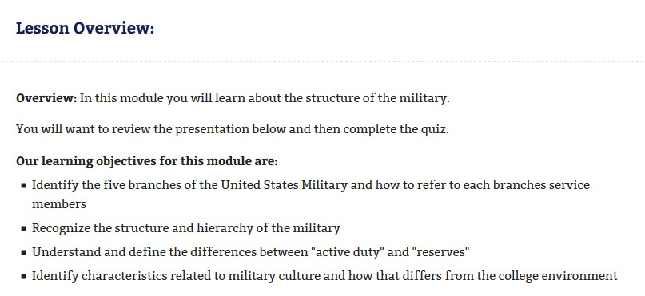

The user will then review all items listed under the Materials area of the training. After they have completed reviewing materials, they will move onto the assessment area of the training. In this area, they will find a quiz, a discussion board to discuss key topics and a survey for the module.

The objectives of this plan are that the faculty of Stark State College will be able to:

* Assist Veteran and Military students by educating them on services available.
* Identify the five branches of the United States Military and how to refer to each branches service members
* Recognize the structure and hierarchy of the military
* Understand and define the differences between "active duty" and "reserves"
* Identify characteristics related to military culture and how that differs from the college environment
* Identify and understand the challenges vets have from transitioning from the military to the college environment.
* Explain the concept of an “invisible scar”
* Identify the different types of “invisible scars” and how they impact education and learning
* List veteran-related resources
* Identify possible accommodations and the process to obtain accommodations
* To understand and identify culturally sensitive ways to approach and discuss military experience
* To identify potential classroom challenges and strategies for success
* To improve the classroom experience for veterans on campus
* To identify and understand the Military Leave of Absence policy for Stark State College
* To identify and understand faculty and veteran options in the case of Military Leave of Absence
* To review examples/scenarios of successful course completion

**Training Plan**

In order for this training to be successful, faculty will complete each module; reading, listening and digesting all information that is given. Then faculty will complete the module by answering the exit ticket questions at the end of each module (Forms) and a survey (Forms). This will allow our evaluators the opportunity to see which of the faculty has taken the time to learn each module and to see what knowledge they have gained.

## **Assessment Plan**

After the completion of each module, an assessment is taken based on the presentation they just completed. Employees need to take all five modules and must have an 85% to receive their certificate. After completion of each module, it is graded and employee receives credit. Employees do not need to complete the modules in order. The training is not required by employees. The assessment after each module is a Google Form quiz based off the interactive articulate presentations and aligned to the objectives for each module. It has been determined that if they complete and pass all modules with an 85% or higher, they will receive a flag for their office door that identifies they are Military Trained Faculty.

# Implementation Report

A soft implementation was done for the evaluation phase. This consisted of five full-time and part-time faculty members that work with students. Three of the faculty members are full-time and two are adjuncts. None of them have served in the military. This was the selection criterion since those who were involved with writing the content are former military. We wanted to ensure the content was understandable for those without service. Two of the participants sat through the initial face-to-face training that was offered 2018. We also asked two of the counselors in Disability Support Services to evaluate the training. They both work with military students so their feedback will be helpful for the formative evaluation.

The timeline for the soft implementation:

|  |  |
| --- | --- |
| **Date** | **Action** |
| 10/31 | SME worked with group to identify the test group for the soft implementation. |
| 11/1 | Contact test group to ask if they are willing to participate in the implementation. |
| 11/4-11/6 | Formalize survey questions that will be used for the test group. |
| 11/7 | Add test users to Blackboard training |
| 11/7 | Email test users to inform them they have access to the training to evaluate. |
| 11/10 | Evaluate the survey results. |

For the full implementation of this training, we will focus on all full-time and part-time faculty members of Stark State College. Lisa (the SME) will email all the faculty to alert them that there is a new training. She will advise them that they can currently access three modules and two additional modules will be available in Spring 2020. In the email, she will provide directions for faculty to use to sign-up for the training. These directions state to register they needed to log into the myStarkState, click on the professional development page, locate the training and then click on the form to register. [The form they use to register can be accessed by clicking here.](https://forms.gle/JuQ2dz8Hz3a2oSDE6)

Once they complete the registration form, a member of the eStarkState team will enroll them in the training. The participant will then receive an email indicating they have been enrolled with directions to access the training. It should be noted that this implementation is planned for December 2019. The goal is to use the evaluation from the test group to update the training prior to releasing it to additional faculty members at the college. Faculty will be advised that two additional modules will be added in January. So they may begin the training but will need to go back later to complete it. We recommend all modules be active before it was sent to faculty but the SME did not agree with this recommendation. She wants them to have a preview of what will be in the training.

Once the faculty member registers for training, they will receive this email:  
  
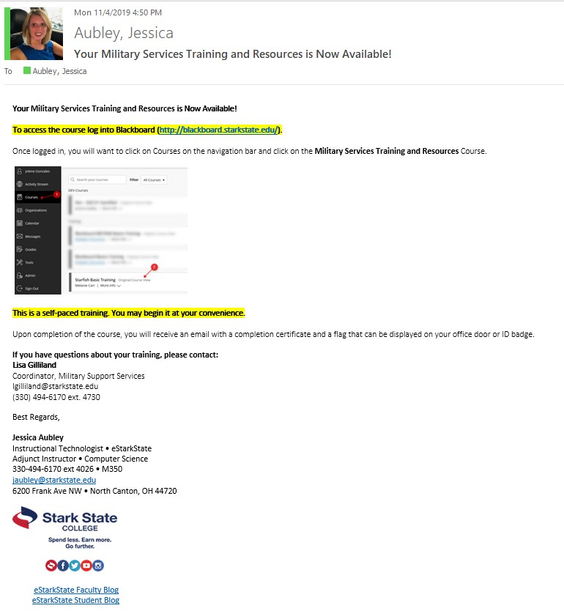  
The timeline for the full implementation:

|  |  |
| --- | --- |
| **Date** | **Action** |
| 12/2/19 | Final approval from the Dean of Student Services. |
| 12/3/19 | Lisa to email all faculty to advise them of the new training and provide directions on how to register for this training. |
| 12/4/19 and on | eStarkState to process registrations for faculty and send them out an email advising them how to access their training. |
| 1/5/20-1/20/20 | Lisa to work with Jessica to create the last 2 modules of the training. Once they are completed, she will alert faculty that they can finish the training. |
| 1/20/20 | eStarkState to check the training weekly and provide Lisa with a list of who has completed the training. |
| 1/20/20 and on | Lisa will issue completion certificates and flags for those who have completed the training. |

# Evaluation Report

To evaluate the training, we have worked with our SME to identify five full-time and part-time faculty members. Three of the faculty members are full-time and two are adjuncts. None of them have served in the military. This was selection criteria since those who were involved with writing the content are former military. We wanted to ensure the content was understandable for those without service. Two of the participants sat through the initial face-to-face training that was offered in 2018. We also asked two of the counselors in Disability Support Services to evaluate the training, they both work with military students so their feedback will be helpful for the formative evaluation.

Lisa requested these two be part of the review since they could possibly provide feedback on anything else they experienced in face-to-face versus the online version. Our team felt having a small test group like this would give us a good insight of our prototype and any additional items that needed added to it. It should be noted that the participants only evaluated the Modules 1-3 of the training. Modules 4 and 5 will be developed during the Spring semester and launched later. While this is not ideal, our SME has not had the opportunity to write the presentations for those two modules.

    Lisa (our SME) was at a conference during the evaluation phase so she gave our team permission to contact the selected faculty members directly. Each faculty member was emailed individually so they did not know who else was participating. These emails included a thank you for being willing to participate in the training and the request for them to evaluate the training before Friday, November 8th. They were provided with a link to a Google Form to complete the survey.

Example of the email used:  
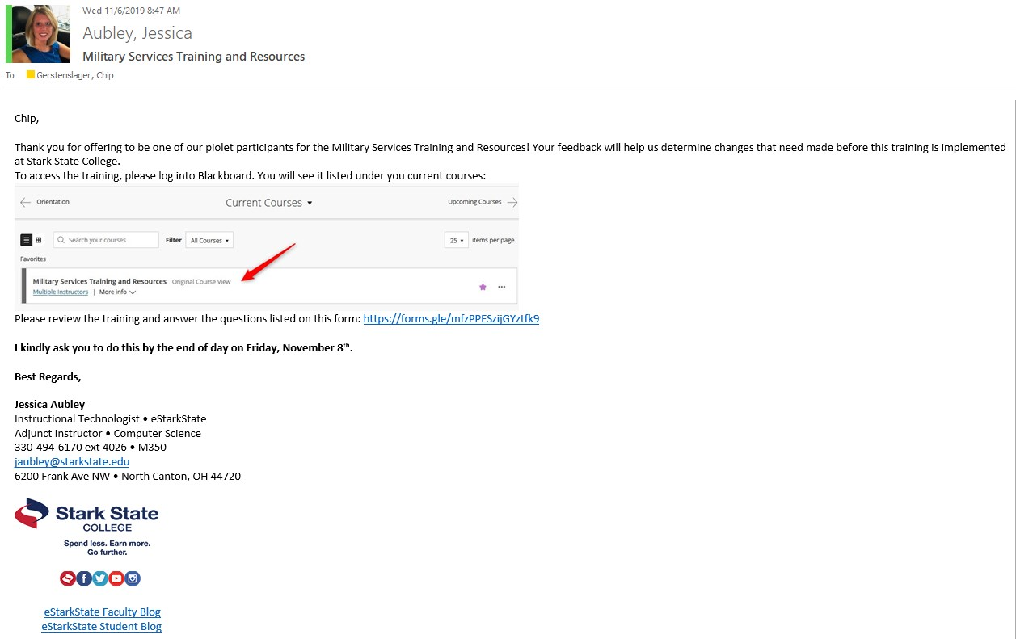

**Survey Questions** We chose to provide the test group with a survey. This survey had several questions regarding the navigation of the prototype, content and assessments that were used. Our goal was to have a full understanding of the test groups experience. We felt one survey with all the questions would be ideal to use for both our formative and summative evaluations.

Questions to be used on the formative evaluation:

* Is the training easy to navigate? If not, what suggestions do you have for improvements?
* Were there any links that did not work properly? If so, which ones?
* Are the materials easily accessible?
* Is the organization and structure on each page appropriate and enhanced learning?
* What additional suggestions do you have for improving the layout of the training?

Questions to be used on the summative evaluation:  
Is the content information clearly and concisely presented?

* Is there any content you felt was confusing?
* Did you find the assessments challenging? Do you have any suggestions for changes?
* What additional suggestions do you have for improving the content of the training?

**Evaluation of Survey Results and Planned Revisions**

Our surveys provided us a good amount of insight on the training. By having formative evaluation questions, we were able to understand the experience that the test group had and suggestions on modifications and improvements. It offered insight from a third party to see if the trainings are easy to navigate through. Most of the feedback was good and some items that were celebrated included the organization and structure used in the prototype. The homepage allowed for understanding of the course and told the users how to get started.  Having questions like this offer constructive criticism and everyone benefits.

The participants stated the content overall was not confusing and it was easy to follow. All participants said that our training was well organized and easy to navigate. They commented that it was designed like other trainings they have taken at the college. We provided this information to the SME. She was pleased to hear no structural changes needed to be made. We followed the Quality Matters designed template that Stark State College uses for all their training, this is the reason we believe we had positive feedback in this area.

The summative evaluation results from our survey, were positive. The lectures used were well done and enhancement using the video lectures provided easy understanding of the objectives. The assessments were challenging for all participants. They said that watching the lectures definitely helped during the assessments. One comment was that the lectures were very informative. And it helped them stay actively involved. There were also comments that the videos and assessments were easily accessible and the use of closed-captioning was appreciated.

 A couple suggestions were made in terms of revisions that could be made. The videos narration and the people in the videos were off and hard to understand. The surveyor stated the closed captioning helped with following along. This could be noted when clicking on the video. Another item that was addressed in Module 3 dealt with the advancement of one slide to the next. The advancement to a different slide could be confusing to the user. A suggestion that was given mentioned leaving modules closed until one is completed. This would make sure the user follows and completes each module correctly.

This feedback was discussed with our SME. The advancement of the slides on the interactive lecture will was addressed and corrected. The video narration was discussed in depth and reviewed with our SME and her team in Military Service. They felt the narration met the needs of the audience and have opted no to re-record the lectures since there is closed-captioning. Our SME did agree that future lectures for Modules 4 and 5 will only have one person narrate them instead of two to ensure the narration sounds smoother. The idea of having modules open after the next was completed was also discussed and agreed upon. Jessica will set adaptive releases on all content in Blackboard. The user will need to complete a module’s assignments before the next module will open. This will ensure that users have a good understanding of where they left off. It should be noted that this option is not available on Google Sites so we cannot show it on the prototype example.